MKCL’s Knowledge Lit
Skill Development Program

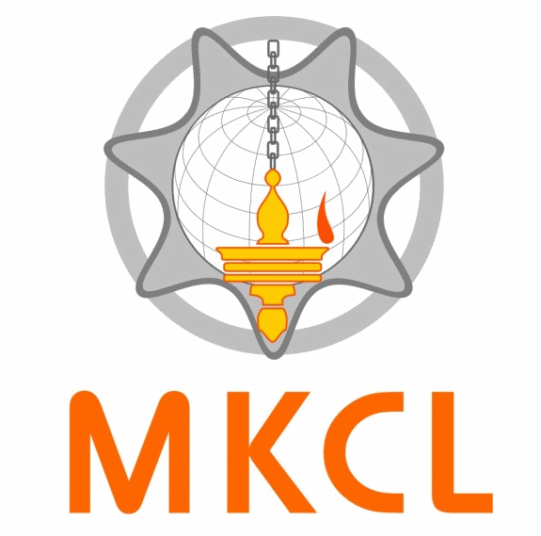
English
Creating a Knowledge Lit World
www.mkcl.org

Work in Web Design
Industry with Excellence

Web Designing
KLiC
Work in Web Desing
Industry with Excellence

